**NHAI -NATIONAL HIGHWAYS AUTHORITY OF INDIA VEHICLE BILLING**

* It is a project which has a automatic bill generating and storing of the vehicle which is in the toll plaza
* In the front panel,we have a button called VEHICLE IN when the vehicle came inside the button should be on and when this is pressed ,a button called GATE STATUS will be ON .
* There will be the crediantials like customer’s name,vehicle no,cash payment,vehicle type,way,booth no and password
* When the vehicle is in,we should fill the following crediantials .
* There will be a DISPLAY which displays all the details which we have entered and it generates like a bill
* When the mode of payment is TRANSACTION,we should fill the correct password and if it is wrong ,it comes out of it
* There will be a button called SUBMIT and if it is pressed, a word file with the display details will be created on the operator name what we have given on the desired path
* At the same time,an excelsheet will be generated on the name of date which contains all details of the customer on that particular date on the desired path
* A button called PAID will be on the first panel ,if it is pressed ,PAYMENT PROCESS light will be glowed and the GATE STATUS will be off
* This is the overall view of the project
* 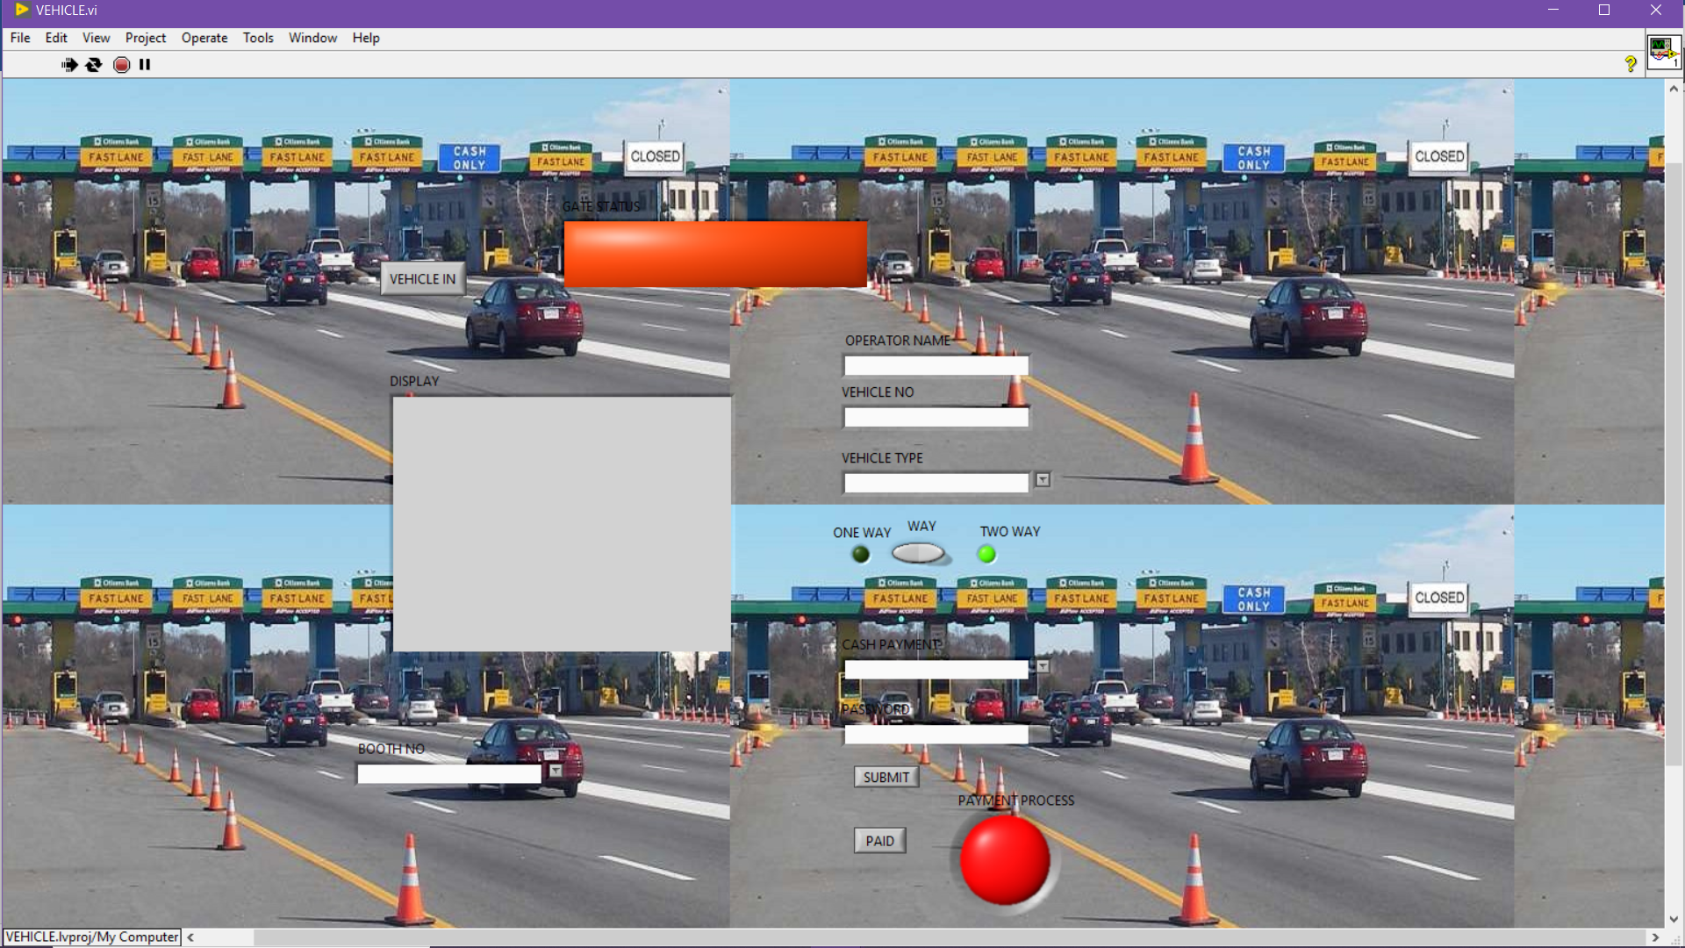

When VEHICLE IN is pressed,GATE STATUS will be ON

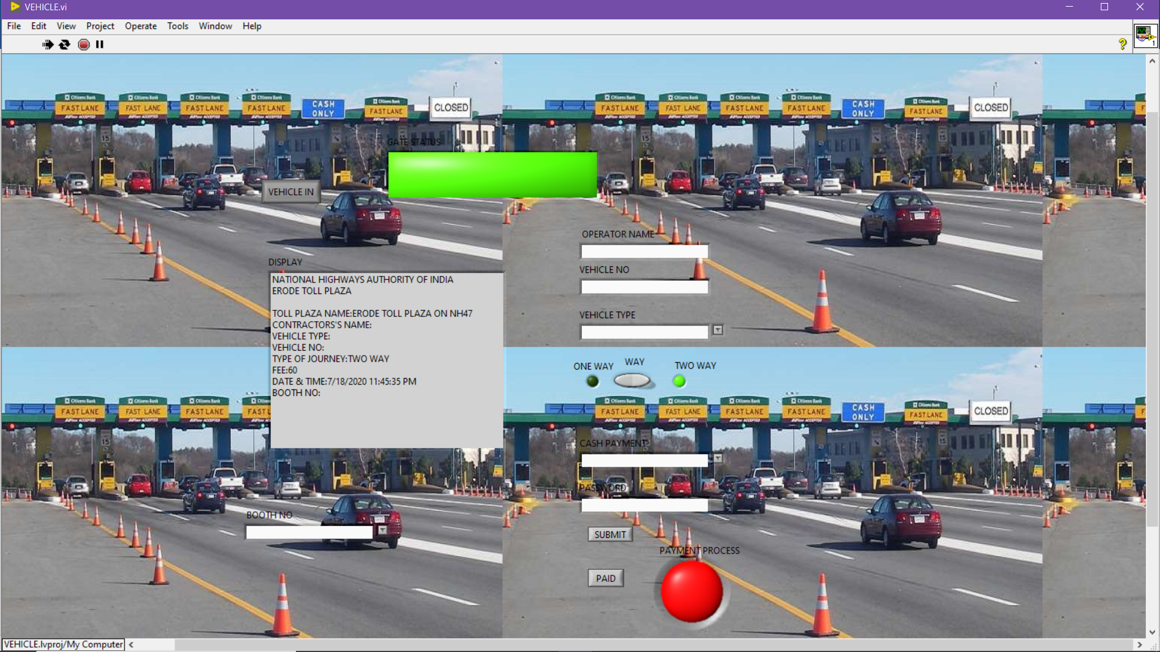

When the details are filled,DISPLAY generates the details like a bill

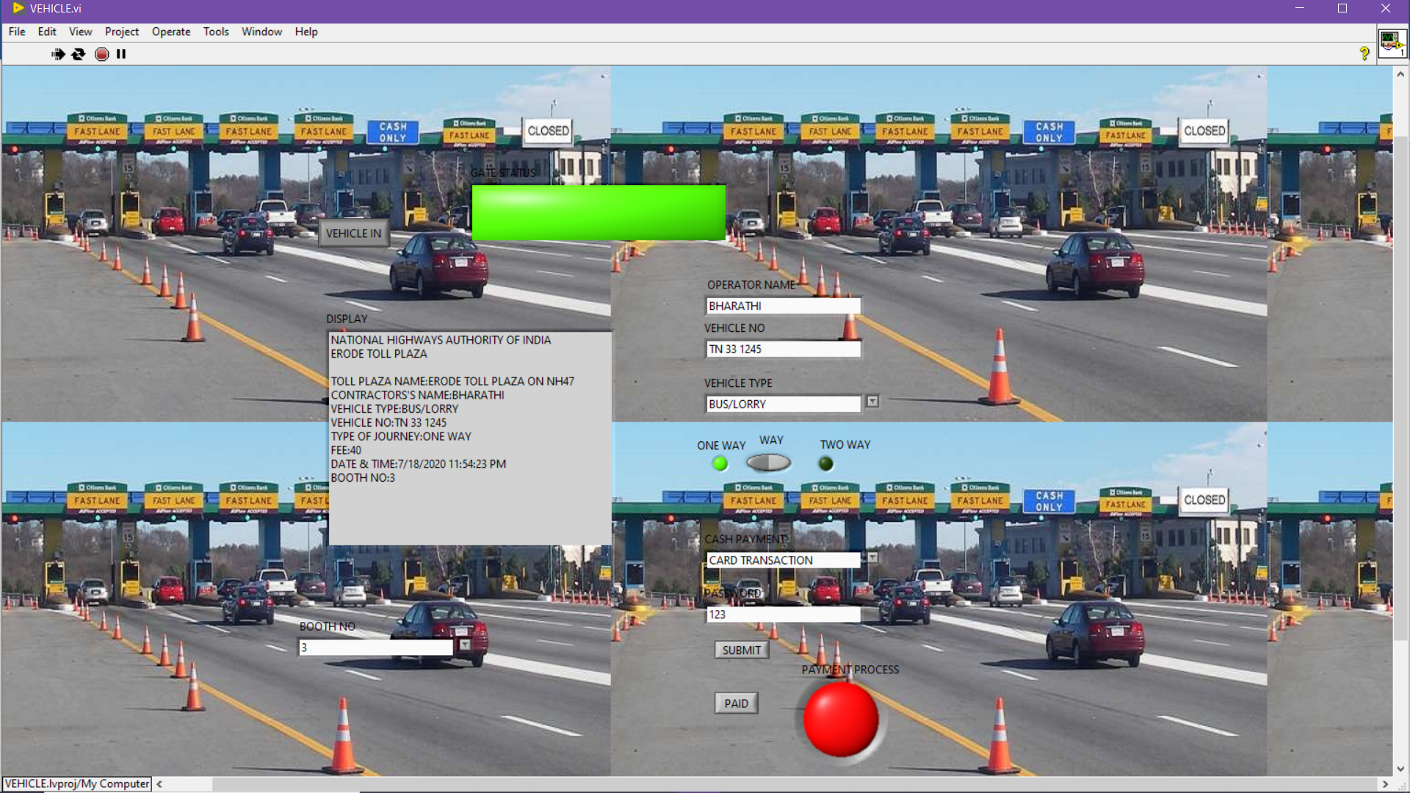

When we choose one way,fee will be 40 and when we choose two way fee will be 60

When SUBMIT is pressed both word file and excel file be generated on the desired path

FILE LOCATIONS:

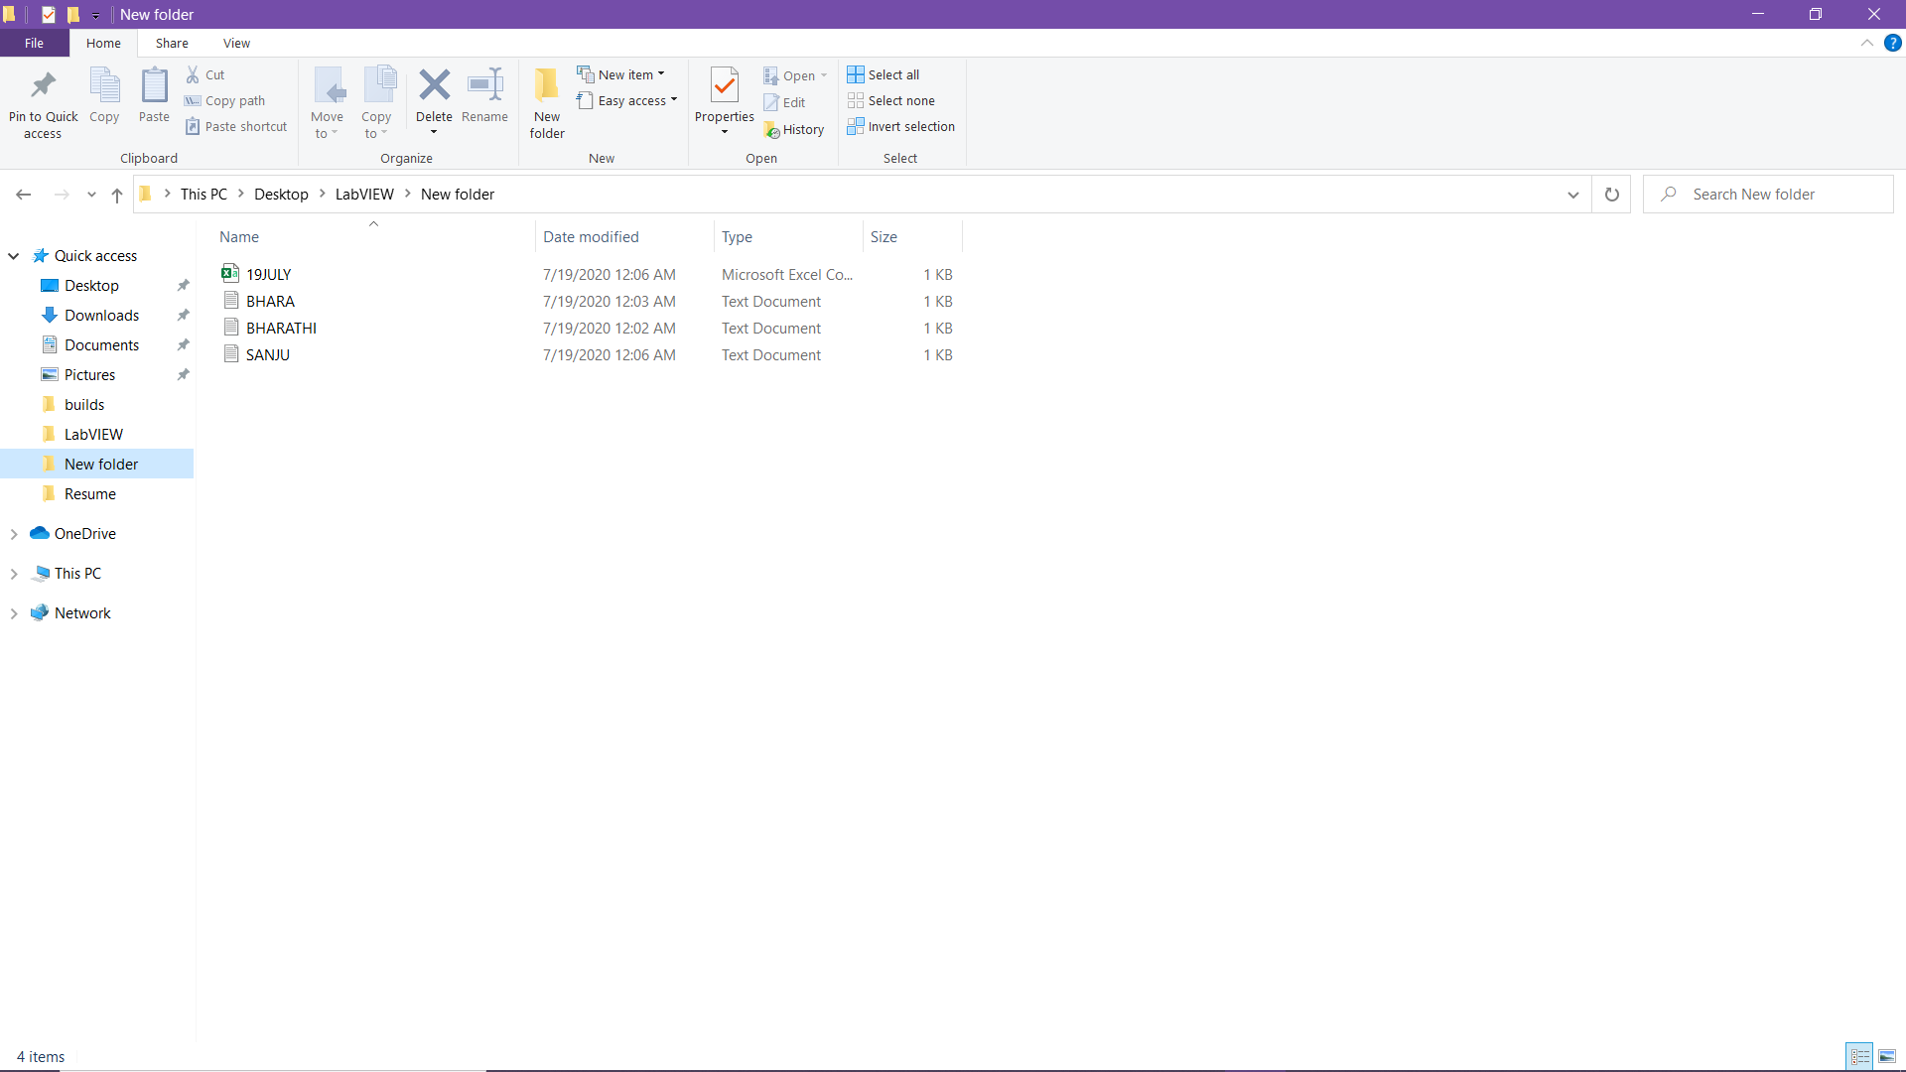

WORD FILE:

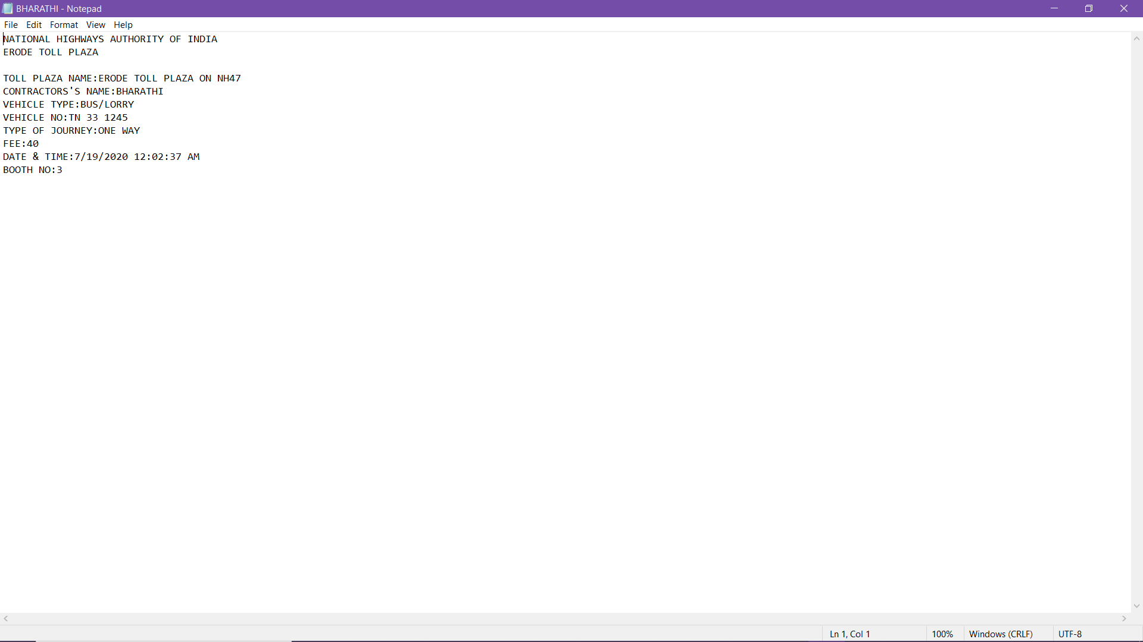

EXCEL FILE CONTAINING ALL THE CUSTOMER’S INFORMATION ON THE PARTICULAR DATE:

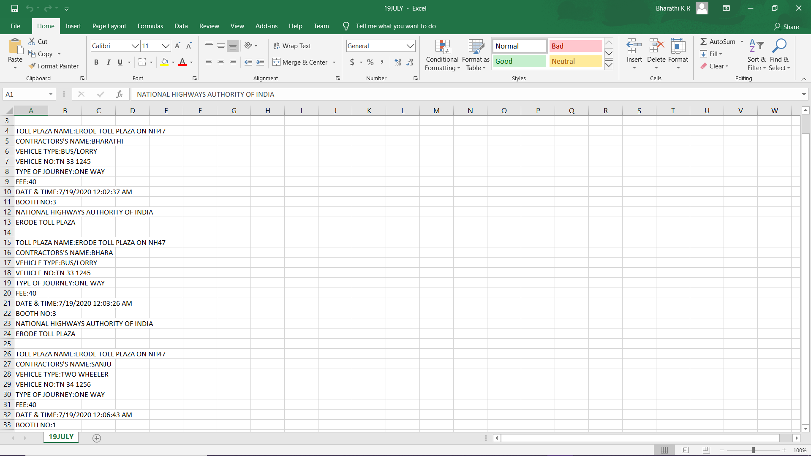

When PAID is pressed,PAYMENT PROCESS will be ON and GATE STATUS will be OFF and DISPLAY will be erased

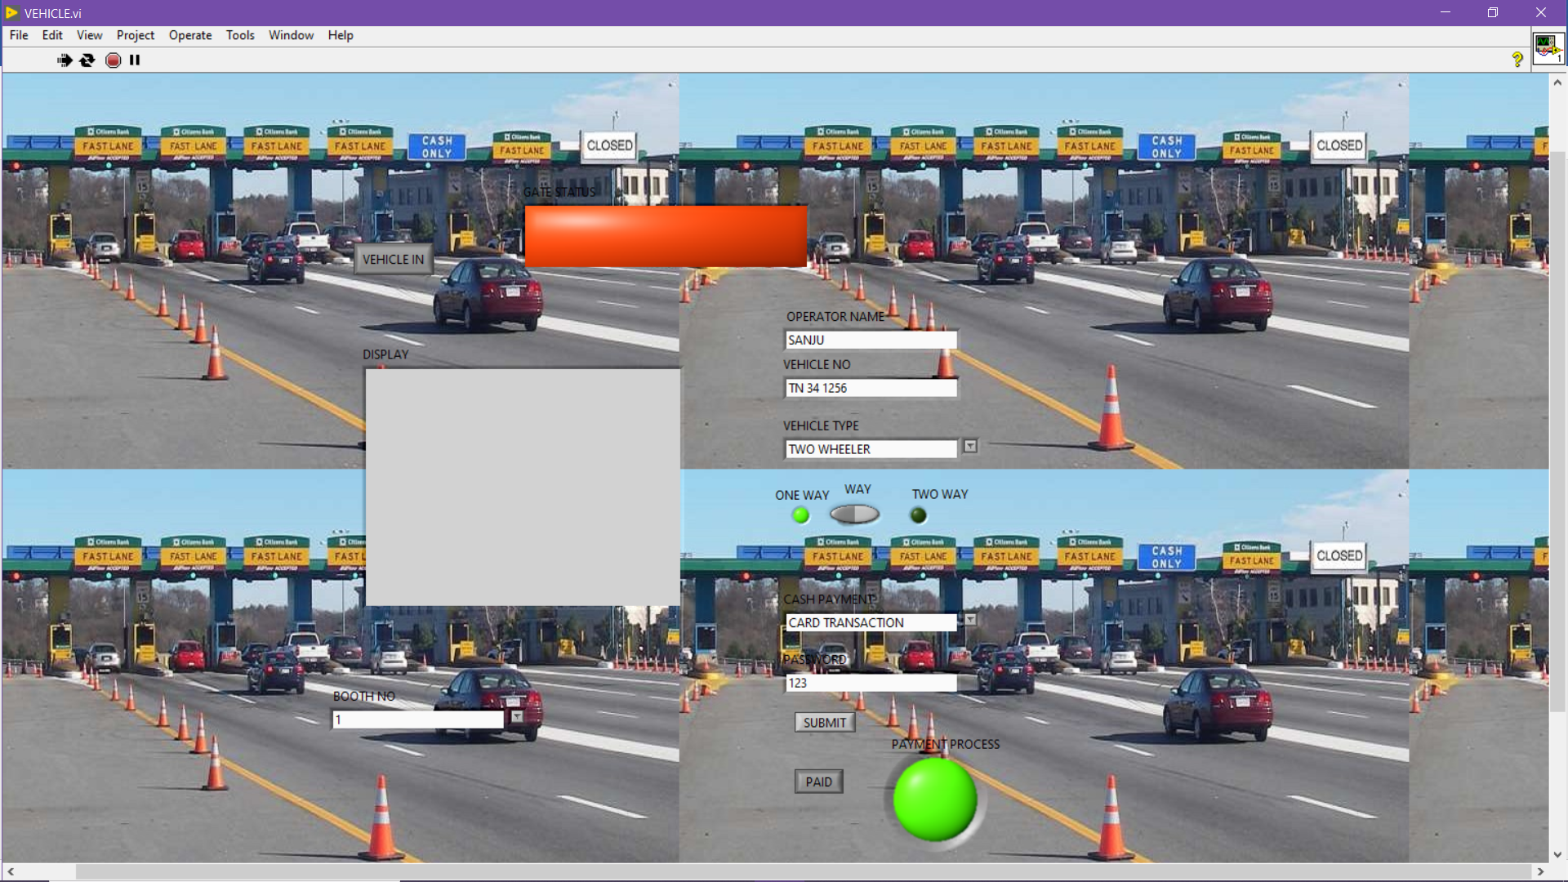

BACK PANEL:

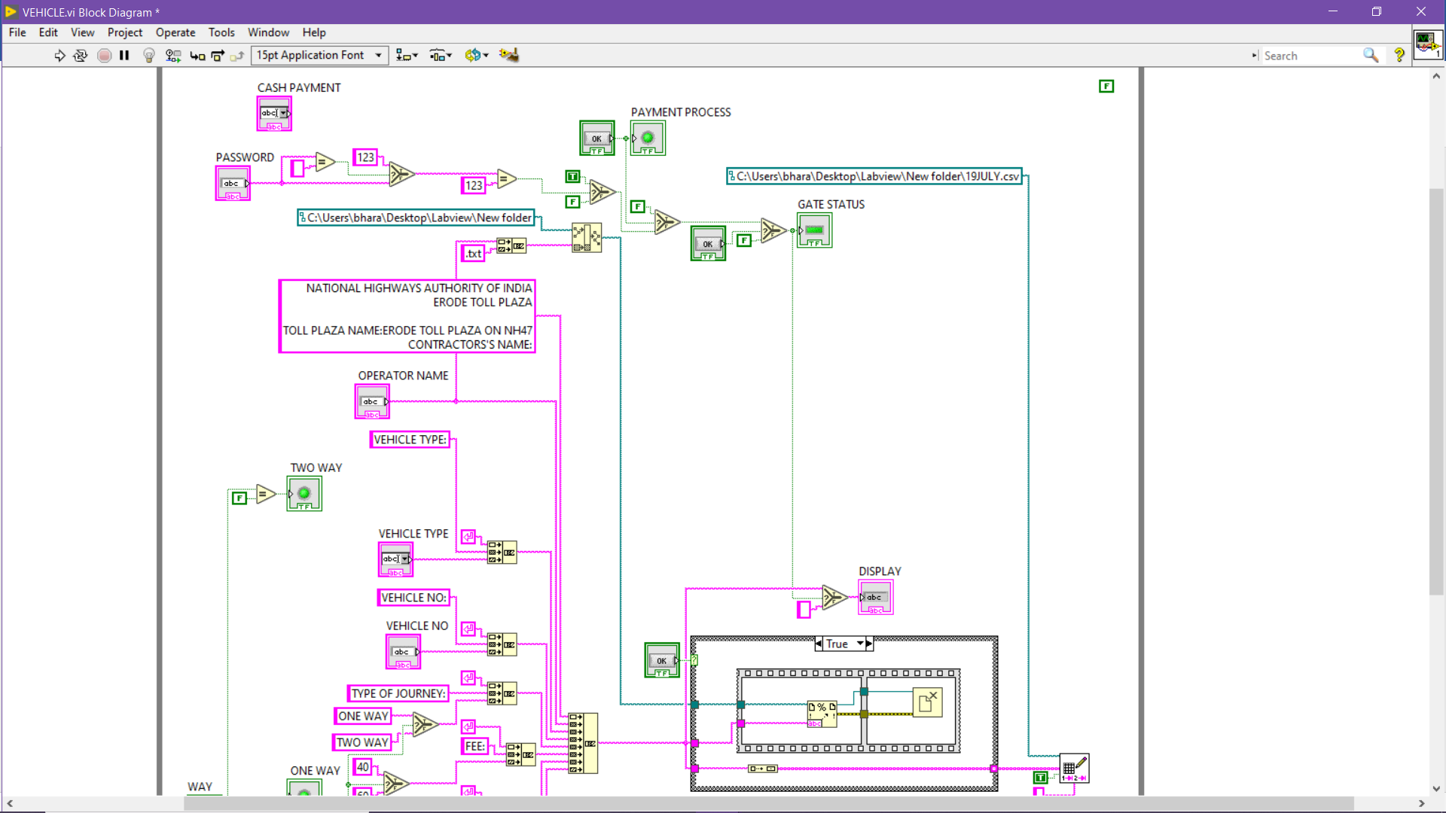

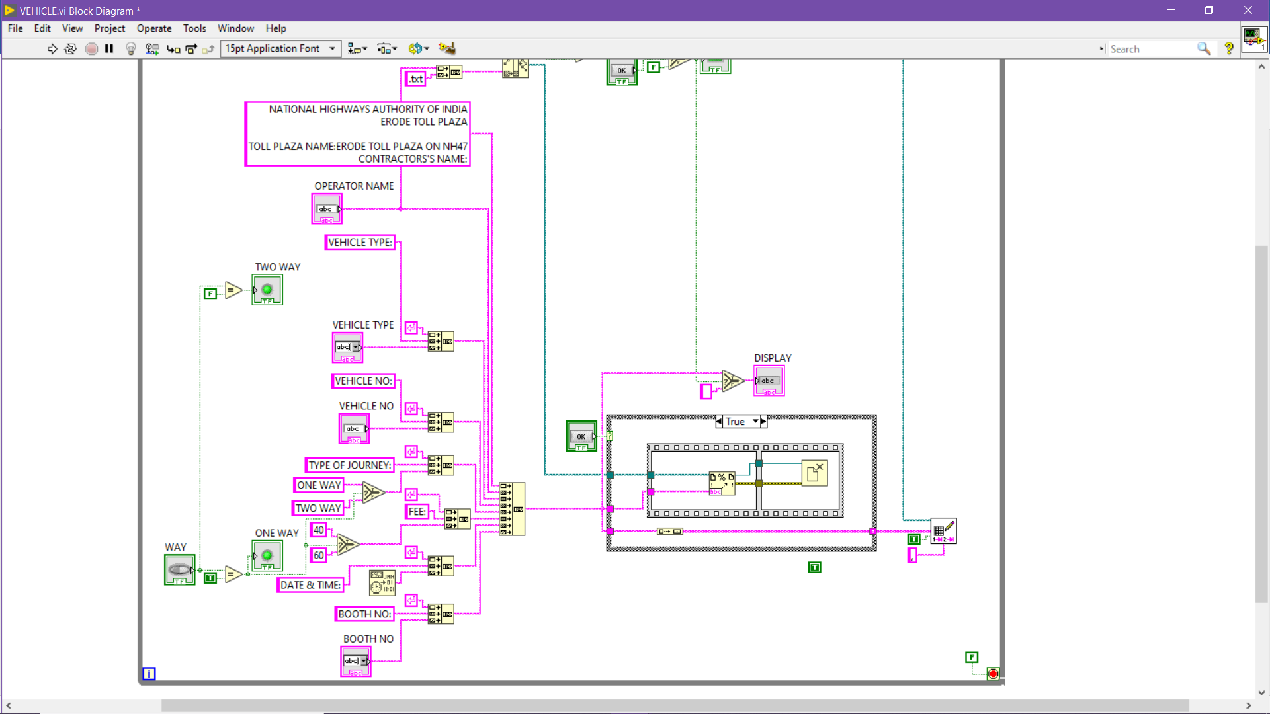

I developed this vi as a Application.exe and as installer

DIFFICULTIES FACED:

I faced more struggle in the excelsheet appending and later on I solved it .This was a great experience and challenge for me.